|  |  |
| --- | --- |
|  |  |

HUMANITARIAN PROJECT FUNDING APPLICATION

|  |  |  |
| --- | --- | --- |
| 1. | Project name | « School - territory of health» |
| 2. | Organization name | Polotsk Secondary School No. 6 |
| 3. | Physical and legal address of the organization, telephone, fax-mail | Polotsk, 8 Marinenko str;  phone: 8(0214)77-34-42;  e-mail: sch6@polotsk.edu.by; |
| 4. | Organization information | Polotsk Secondary School No. 6 was built in 1987. In 1994 the educational establishment received the status of a school with a musical and choral bias. Since 2016 the school has been implementing an interdepartmental information project «School – Territory of Health». A resource centre with methodological materials has been created on the basis of the educational institution, as well as a thematic school website "Promotion of a healthy lifestyle among students and their parents". Today, the resource centre has about 20 different methodological issues. During the project implementation, the school has been equipped with valeological corners in classrooms and offices. The foyers on the 1st and 2nd floors are equipped with special tables for playing table tennis. Sports recreation with special flooring was equipped; nets for windows, Swedish walls and basketball rings were purchased. As part of the project, the school maintains the following interdepartmental relations:  1. 1. Polotsk Central City Hospital" State Health Care Institution;  2. 2. "Children's clinic";  3. The Traffic Police;  4. Ministry of Emergency Situations;  5. 5. "Environmental Department";  6. Branch of the library № 3;  7. Belarusian Republican Youth Union, Belarusian Republican Pioneer Organization, Juvenile Affairs Inspectorates;  8. 8. "Mothers against drugs";  9. 9. Teen-friendly center "Revelation"  **Features of our educational institution**  A special feature of our educational institution is the use of the recreational and psychotherapeutic potential of activities such as choreography, vocal and musical creation: 532 out of 845 students at the school attend musical and choreographic elective courses. Singing, music and dance classes not only contribute to the development of children's physical qualities, but also help to achieve emotional relaxation, relieve mental strain and fatigue. It is not without reason that the creative groups of the school, two of which have the status of "exemplary", are laureates and diploma holders of music and dance competitions at the regional, national and international levels.  **Achievements:**  Well established cooperation between family and school allowed the institution to become a winner of the Republican contest for the best implementation of the interdepartmental project "School - territory of health" in 2018 as a school that promotes health through the implementation of measures in the system "teacher - pupil - parent". In November 2019, the institution took part in the 5th European Conference of Schools for Health Promotion. The event brought together 456 participants from different countries, including 14 representatives of the Republic of Belarus. From the Polotsk District the Conference was attended by teachers of the state educational institution "Polotsk Secondary School No 6". |
| 5. | Headmaster | Headmistress of Polotsk Secondary School No. 6 – Ludmila Haviazo.  Phone: 8(0214)77-34-42 |
| 6. | Project Manager | Deputy Director for Educational Work – Ilya Lyakh.  Phone: +375(33)604-24-30 |
| 7. | Previous support received from other foreign sources | No experience of cooperation with foreign partners. |
| 8. | Required amount | For material and technical equipment of the gym we will need: 100.403 BYN or 39.751 USD  Sponsorship help – 12.000 USD  Co-fynding – 27.751 USD |
| 9. | Co-funding | Directorate for Education of the Polotsk District Executive Committee. |
| 10. | Project term | From 01.09.2023 to 01.09.2026 (there is a possibility of project implementation for a longer period)  Stage 1 - preparatory (1 year):  - Development of the project "School – territory of health";  - Assessment of the conditions under which it is possible to achieve the goal;  - Identification of the problem and justification;  - Implementation of instructional and methodological work with project participants.  Stage 2 - approbationary (3 years):  - introduction of forms and methods of health saving educational technologies of education and training;  - Systematic educational and training work to promote a healthy lifestyle.  Stage 3 - control and generalization (1 year):  - Evaluation of the results of work on the project;  - Preparation and formulation of conclusions and recommendations. |
| 11. | Project aim | Building a healthy educational environment based on the ideology of a health culture, which implies the formation and the organization of a healthy lifestyle of the educational institution. |
| 12. | Project Purposes | - to keep a close eye on the school's health and hygiene;  - hygienic rationing of teaching load, amount of homework and daily routine;  - mastering by teachers of new methods of activity in the process of schoolchildren's education, the use of lesson technologies that save the health of students;  - The systematic organization of a full and balanced diet for pupils, taking into account the specifics of their health condition;  - Prevention of pupils' psychological and physiological condition;  - Involvement of the system of circular, extracurricular and extra-curricular activities in shaping a healthy lifestyle for pupils;  - Participation in the compilation of experience by familiarizing students with the work of health schools and attending scientific and practical conferences, seminars and lectures on the issue;  - Creating a way of life for the school that preserves the health of children and teachers.  - Introduction of innovative technologies in the educational process, preserving the health of teachers and students.  - Creating a system of physical education and health-improvement work.  - Development of programmes to involve children in research activities.  - Creation of motivation for a healthy lifestyle;  - Education of parents in issues related to the preservation of children's health |
| 13. | Detailed description of project activities in accordance with the set objectives | **Project Description**  The project involves joint activities of teachers, students and parents, as well as other interested organizations in preserving and promoting the health of children. The project aims at establishing a value attitude among students, teachers and parents to health and a healthy way of life, at developing skills for preserving and strengthening health, at promoting physical education and sports, at improving physical education and mass leisure activities.  **Project implementation mechanism**  1. 1. Development and testing of a set of diagnostic methods to determine the effectiveness of health saving activities used in the educational institution.  2. Monitoring of children's health condition. Accounting for the morbidity of children, control of physical education.  3. Comprehensive prevention, development and diagnostic and corrective work aimed at preventing and overcoming deficiencies in mental development.  4. Creation of a favorable psychological climate in classes.  5. The organization of work of valeological corners in classes.  6. Promotion of a healthy lifestyle among schoolchildren, their parents and community members.  7. Organization of the work of sports sections and clubs. Involvement of parents in active leisure.  8. Discussing health problems at pedagogical councils, conferences, seminars and consultations. Exchange of experience in preserving children's health with teachers of other educational institutions.  Target audience: work in the system " teacher-pupil-parent".  Responsible: Deputy Director for Educational Work Lyakh I.R. |
| 14. | Project Justification | **Introduction**  The policy that lies at the heart of our future is children's health, so teachers, parents and the public are faced with the challenge of fostering a healthy generation. According to statistics, during the period of children's education, the health condition of some children is deteriorating. Presently, the problem of preservation of pupils' health is not only pedagogical but also has gained social importance.  As a result of the analysis of the general school health map, leading forms of pathologies have been identified. These include diseases of the digestive organs, the musculoskeletal apparatus, the visual organs and the central nervous system. The presence of pathologies is one of the reasons for reduced work capacity and increased fatigue among students. Based on these indicators, we see further ways to implement our project.  **Relevance of the project**  The most valuable thing a person has is life, and the most valuable thing in his life is health, for which it becomes not only urgent, but also economically necessary to fight for. However, in the rating of youth's life values health takes only the 4th place, following the importance of family, friendship and communication, financial well-being. Most schoolchildren know very little about their body, its structure and functions, about health as the main value of man. Because of the lack of basic knowledge, a young man makes many mistakes. Unfortunately, very often these mistakes become fatal. The sooner a teenager has a conscious need to take care of his health, the healthier each particular person and society as a whole will be. The school team sees health as the goal, content, and result of the pedagogical process, as a condition, factor, and criterion for successful interaction between teachers and students in educational activities.  The project "School - Territory of Health", which is of a complex nature, can and should consolidate the efforts of teachers, school administration, school nurse and psychologists, students themselves and their parents in maintaining a healthy lifestyle and physical development of children. Health will always be in the trends, this project is being implemented by all schools of the Polotsk district, thus creating an awareness field of a healthy lifestyle among the whole city and district. |
| 15. | Activities after project completion | **Functions of key employees of the school in the context of the project implementation**  1. Functions of the headmaster and her deputies.  - Overall project management: organization, coordination, control;  - General management and control over the organization of hot meals for schoolchildren;  - Organizing the teaching of valeology in biology and life-skills classes;  - Organizing the control of physical education lessons;  - Ensuring the work of the gym during extra-curricular and vacation periods, sports clubs and sections;  - Development and control of the system of extracurricular activities to improve the physical health of students;  - Organization and control of the work of class leaders on the project "School – territory of health";  - Organization of a data bank on socially disadvantaged families, families in difficult life situations and support for children from such families.  2. 2. Functions of the class teacher.  - Sanitary and hygienic work to organize children's life activities at school;  - Organization and implementation of measures in the classroom to prevent frequent diseases among pupils;  - Organization and implementation of measures for the prevention of child injuries in the classroom;  - Organization and implementation of measures in the classroom to prevent drug addiction, toxic addiction and smoking;  - Organization and conduct of preventive work with parents;  - Organization of meetings between parents and representatives of law enforcement agencies, traffic police, police officers and health workers;  - Organization and conduct of extracurricular activities (talks, debates, lectures, competitions, etc.) in the framework of the project;  - Organization and conduct of research into the level and quality of physical, mental, somatic and moral health of students;  - Organization and conduct of diagnostics of the level and quality of students' knowledge of hygiene, traffic rules, legal culture.  **Expected results of the project implementation**  - Preservation and improvement of schoolchildren's health through mastering the skills of healthy life-saving measures.  - Improvement of physical culture and mass work, organization of active rest.  - Preservation and improvement of teachers' health through the implementation of health saving measures.  - Improvement of students' health dynamics indicators:  - Preserving the contingent of students classified as 1st and 2nd health groups;  - reducing the number of behavioral risks that are dangerous for health (smoking, alcohol, drugs);  -satisfaction with the school of children: parents and teachers - the complexity and consistency of work on health preservation and promotion.  - Improvement of the school's material and technical base (equipment of the sports hall, choreography hall, school canteen, foyer and recreation hall, acquisition of necessary sports equipment and supplies). |
| 16. | Project Budget | For material and technical equipment of the gym we will need: 100.403 BYN or 39.751 USD  Sponsorship help – 12.000 USD  Co-fynding – 27.751 USD |

attachment 1

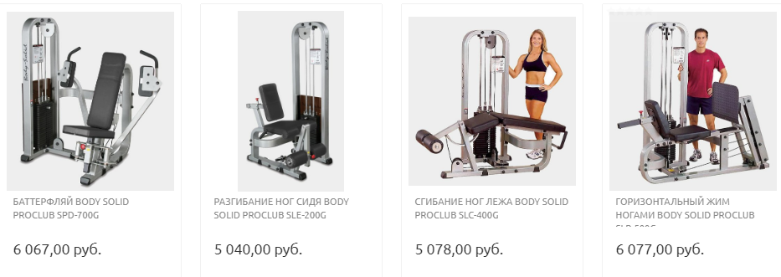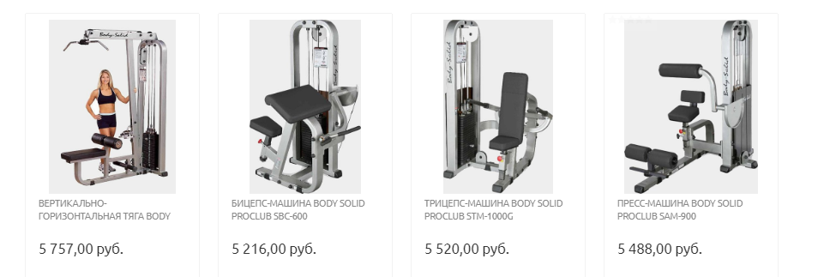

2171.28 USD

2183.94 USD

2063.67 USD

2277.71 USD

2404.32 USD

2009.07 USD

1994.03 USD

2400.36 USD

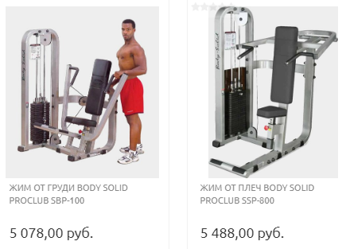

2171.28 USD

2009.07 USD

attachment 2

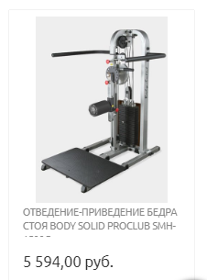

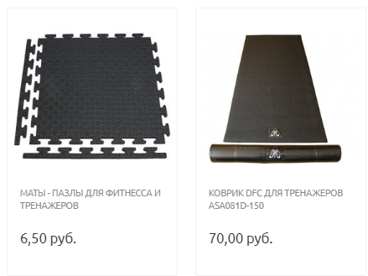

27.69 USD

2.57 USD

2213.22 USD

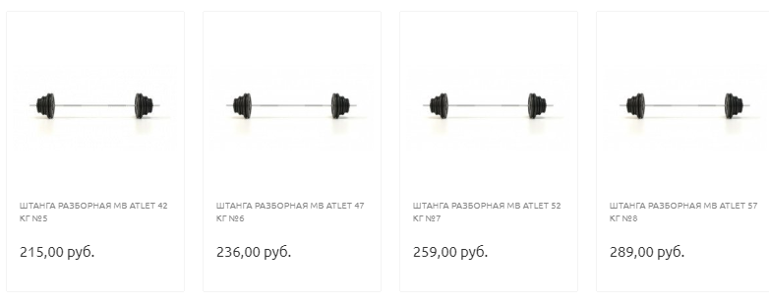

114.34 USD

102.47 USD

93.37 USD



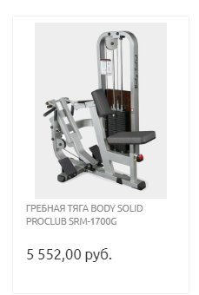

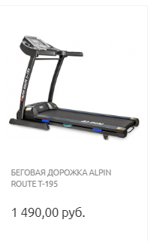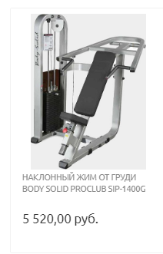

589.51USD (х2)

2196.60 USD

2183.94 USD

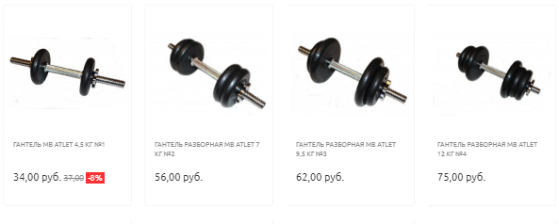attachment 3

29.67 USD (х2)

24.53 USD (х2)

22.16 USD (х2)

13.45 USD (х2)

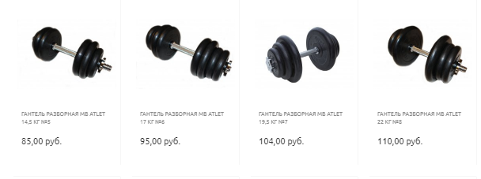

43.52 USD (х2)

41.15 USD (х2)

37.59 USD (х2)

33.63 USD (х2)

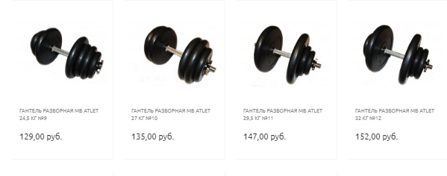

60.14 USD (х2)

58.16 USD (х2)

53.41 USD (х2)

51.04USD (х2)

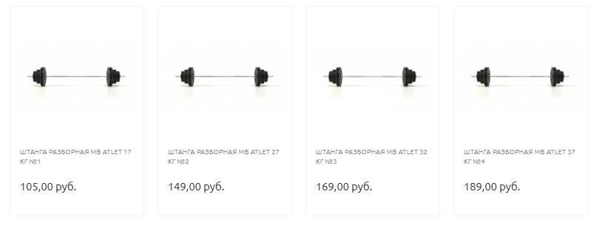

74.78USD

66.86 USD

58.95USD

41.54 USD

attachment 4

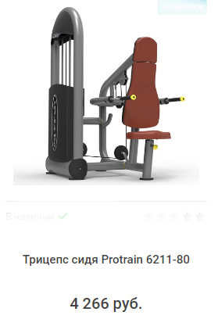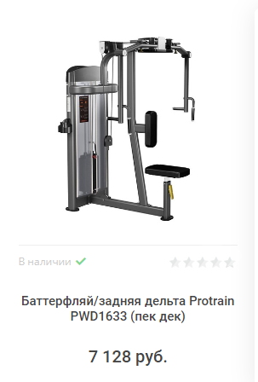

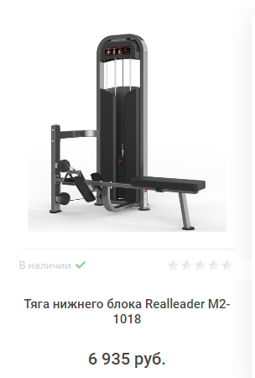

1689 USD

2822.13 USD

2745. 42 USD

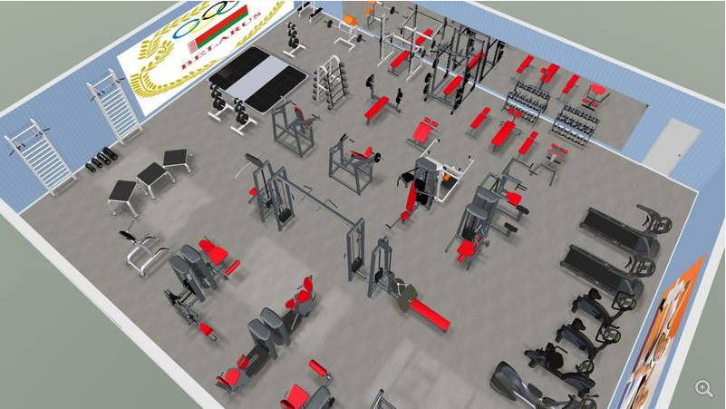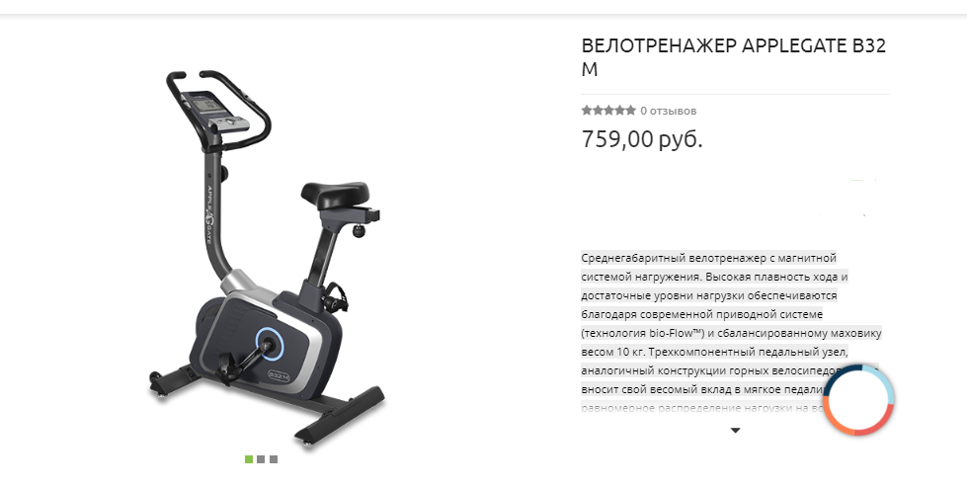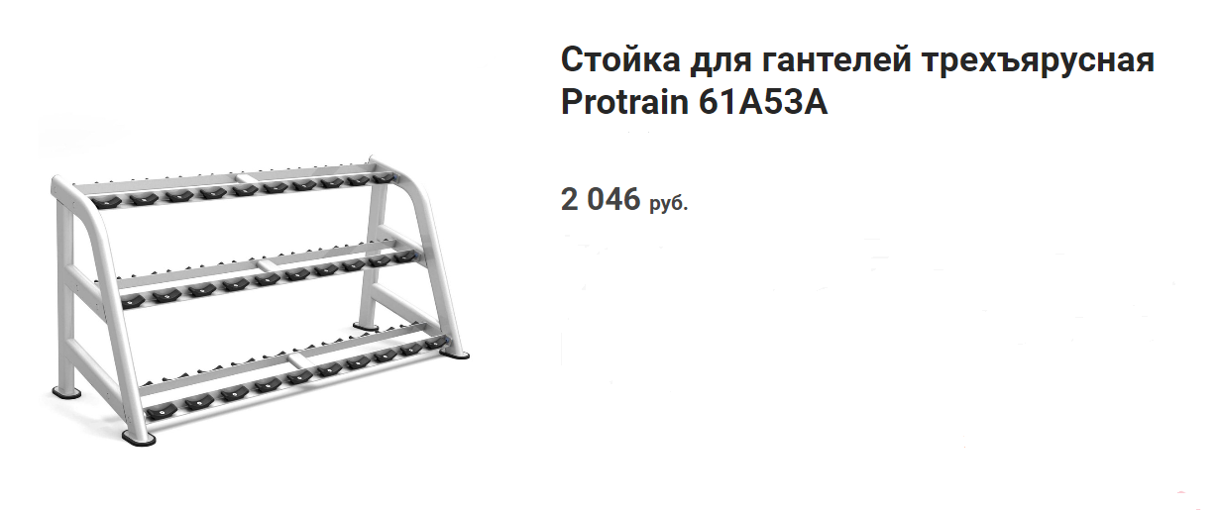attachment 5

300.29 USD (х2)

809.48 USD